Have you completed our business survey?

👉 [https://www.surveymonkey.com/r/DDDCBusinessSurvey2025](https://www.surveymonkey.com/r/DDDCBusinessSurvey2025?fbclid=IwY2xjawIlh8RleHRuA2FlbQIxMAABHaqSGdoitXcoH0AOJATKGzcDhsI0UKX6YZSBUDipkVeCxu7zMbOW7LWl1Q_aem_lC5xXNuuamwYflsAIpZyfA)

**Learn how to join the green agenda**

Learn how to make your business more sustainable on Friday 28th March at [Business Peak District](https://www.businesspeakdistrict.com/)’s Sustainability Summit at the Devonshire Dome in Buxton, in partnership with [East Midlands Chamber](https://www.emc-dnl.co.uk) and the [University of Derby](https://www.derby.ac.uk/).

Through a range of key speakers and member case studies, the focus will be on practical insights for businesses to engage with the green agenda.

Register your free place here: <https://www.businesspeakdistrict.com/events-mec/peak-district-sustainability-summit/>

Tourism businesses – are you up to date with fire regulations?

Did you know that in January the UK Government updated its guidance on for fire safety measures in paying guest accommodation which has a simple layout, limited fire risks and a small number of bedrooms. This includes a small bed and breakfast, guest house or self-catering accommodation. Don’t be caught out!

<https://www.gov.uk/government/publications/making-your-small-paying-guest-accommodation-safe-from-fire>

**East Midlands Chamber Economic Survey – please compete**

The results from this survey form part of the largest survey of its kind in the UK and are recognised as a key economic indicator by the Government, the Bank of England, independent economists and provides data to support lobbying priorities in the East Midlands.

The more surveys that are completed the more robust the results. Whether you are a member of East Midlands Chamber or not please complete it: <https://lnkd.in/e2fwGGjU>

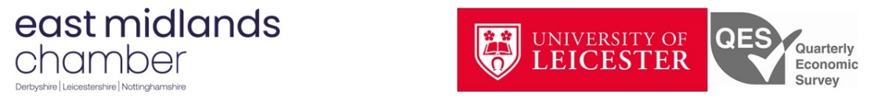

**Free training for tourism businesses**

Don’t miss out on free courses/events to help support your business, such as [Marketing Made Easy for Tourism Businesses](https://www.d2n2growthhub.co.uk/events/marketing-made-easy-for-tourism-businesses/) on 12th March at Grindleford. Funded by Derbyshire Dales District Council and delivered by East Midlands Chamber.



**Derbyshire Manufacturing Network**

The Derbyshire Manufacturing Network’s next meeting is on 14th March (7.30 – 10.30 am, Chesterfield). The aim is to unite local manufacturers, enabling them to harness the cross-industry, business, engineering and manufacturing knowledge necessary to evolve and expand.

Book your free place [here](https://www.emc-dnl.co.uk/events/tmpl_-_derbyshire_dales_and_high_peak_derbyshire_manufacturing_network4006346702/).

